**what is node?**

**ans:-**

**In the DOM, all parts of the document, such as elements, attributes, text, etc**

**are organized in a hierarchical tree-like structure consisting of parents and children.**

**These individual parts of the document are known as nodes.**

Dom Traversing:-

1- it is a relationship between the elements in the form of parent and child.

2- it is used to select the nodes in Dom tree from other nodes.

SEE HTML CODE BEFORE RUN YOUR CODE.

  <div class="container">

  <div class="row">

    <div class="col-md-12">

         <ul class="list-group text-center" id="skill">

          <li class="list-group-item">1 HTML</li>

          <li class="list-group-item">2 Css</li>

          <li class = 'imp list-group-item' id="imp01">3 JS</li>

          <li class="list-group-item">4 Angular</li>

          <li class="list-group-item">5 Sass</li>

        </ul>

    </div>

  </div>

 </div>

SEE JS CODE BEFORE RUN YOUR CODE.

.parentNode Property:-

1- The parentNode property returns the parent element with childrens of a selected element.

Exam-1:-

const sel = document.getElementById('imp01')

const sel01 =imp01.parentNode;

console.log(sel01);

**OUTPUT:-**

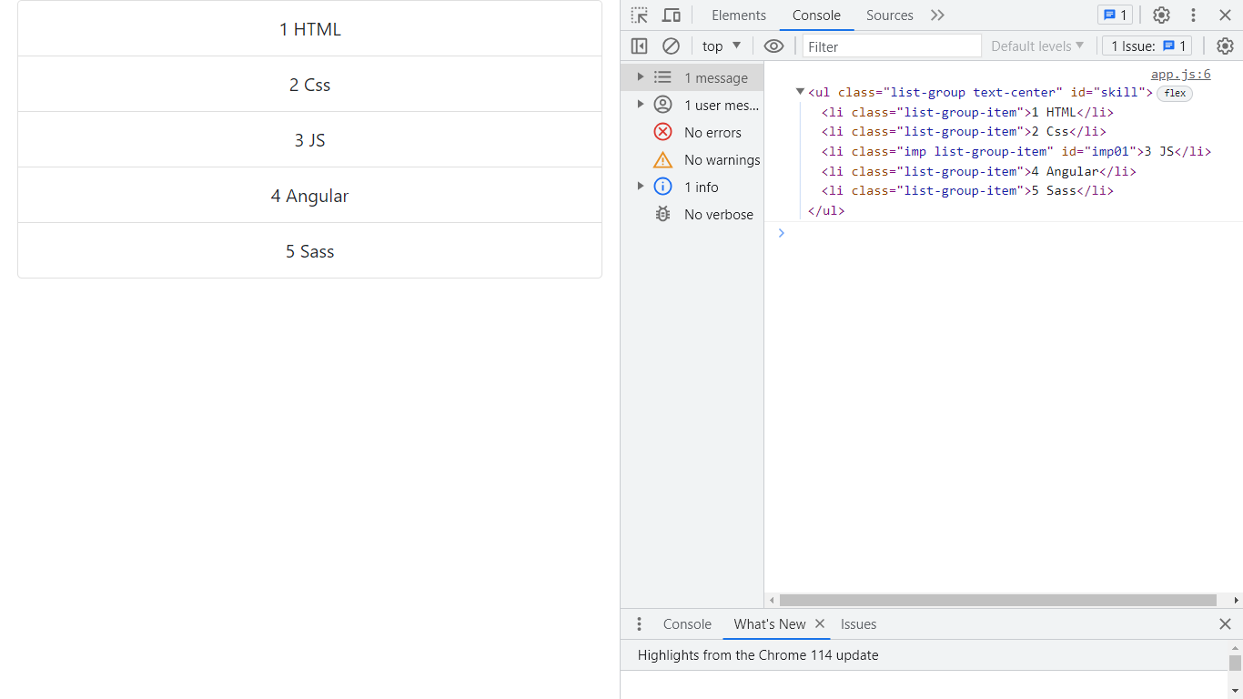

.parentElement Property:-

1. it returns the parent Element with childrens of an element.

The output same as above.

closest() method :-

1- it is a js method which is used to match the specific selector of an element with the given selector

to get the whole element. if it doesn't match so it returns Null.

eg:-1

let sell = document.getElementById('imp01')

let row01 =imp01.closest('.row');

console. log(row01)

**OUTPUT:-**

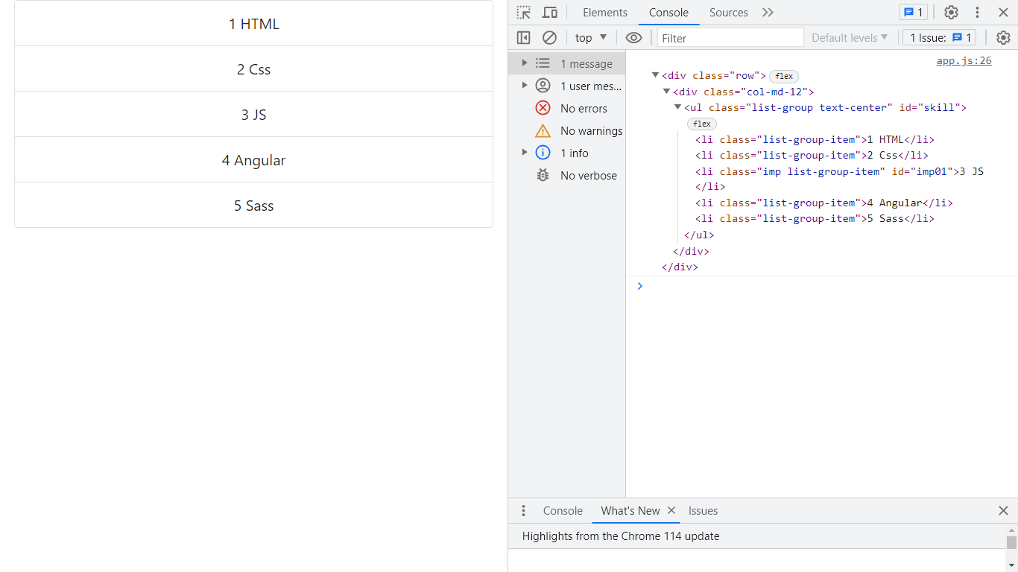

childNodes Property :-

1. it is Dom property which is used to give the NodeList of an element.
2. it also returns overall collection list of an element.

Eg:-

let child = document.getElementById('skill')

let chi01 = skill.childNodes;

//let chi02 = [...skill.childNodes] > here we can convert it into array.

console.log(chi01);

**OUTPUT:-**

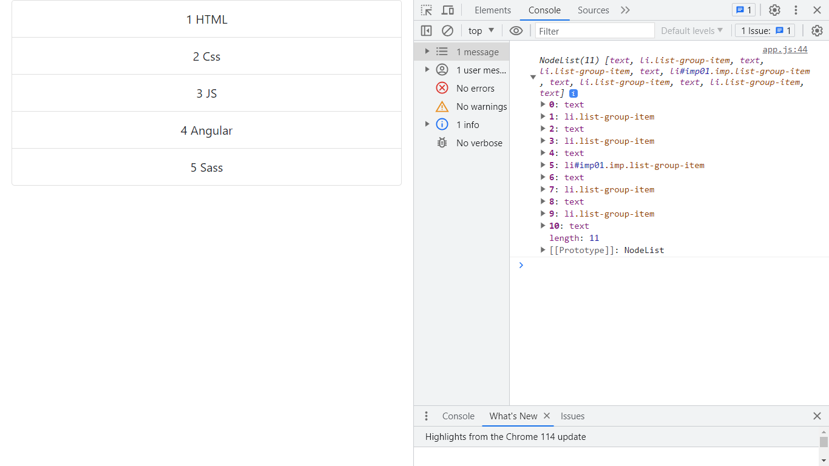

childern property:-

1- it is Dom property which is used to give the HTML Collection of selected element.

eg-1

let d = document.getElementById('skill')

let d01 =skill.children;

// let d02 =[...skill.children]

console.log(d01)

**OUTPUT:-**

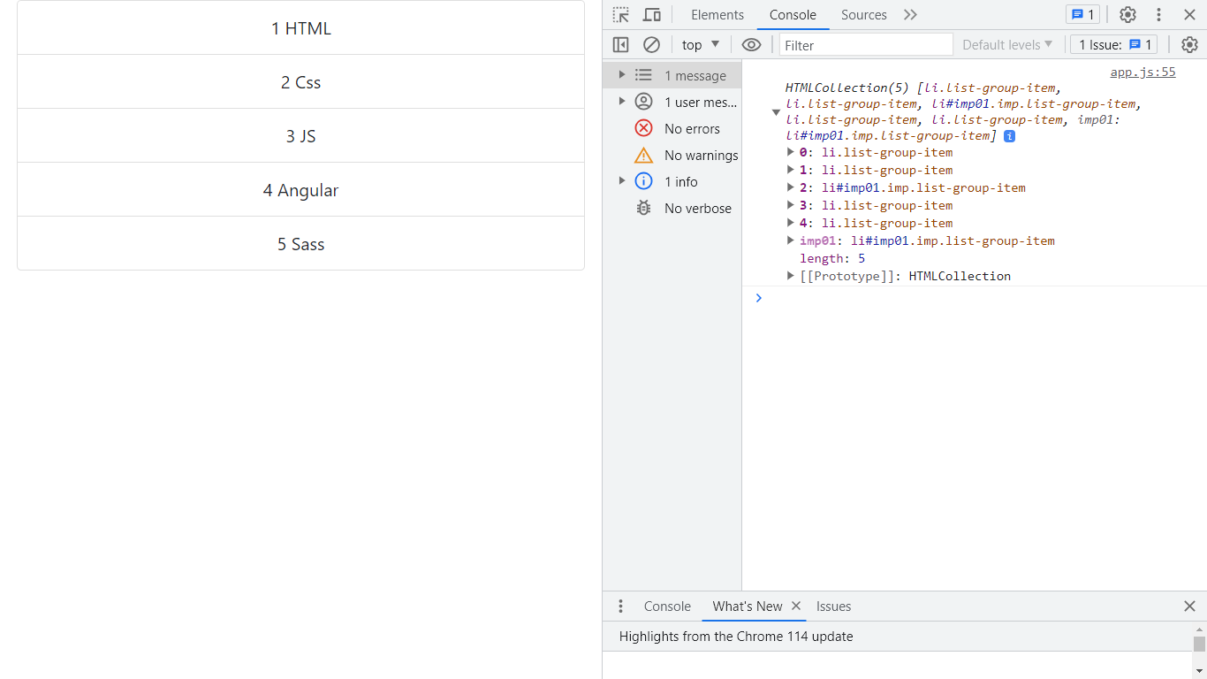

// eg:-2

let sil02 = skill.children[1];

console.log(sil02);

// eg-3

const sel = document.querySelector('#imp01')

const sel01 = imp01.children;

console.log(sel)

1-firstChild Property is used to return the firstchild Node of its parent node element.

//eg-1

let pra = skill.firstChild;

console.log(pra)

**OUTPUT:-**

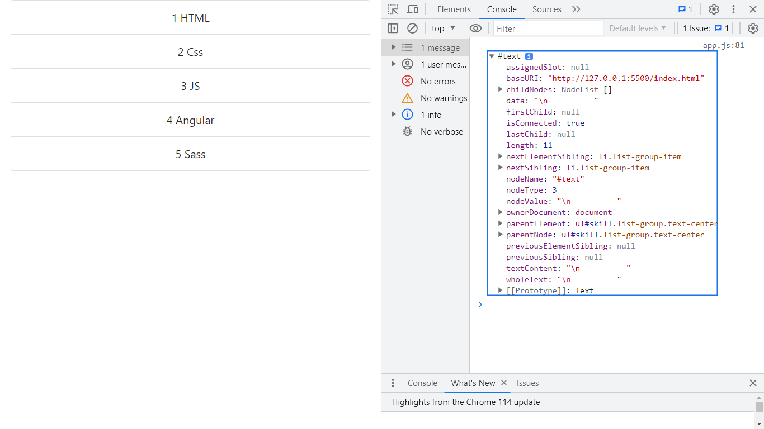

firstElementChild Property:-

1- this property is used to give the First element of the selected element.

eg:-

let sil = skill.firstElementChild;

console.log(sil);

**OUTPUT:-**

<li class="list-group-item">1 HTML</li>

lastElementChild property:-

1- this property is used to give the Last element of the selected element.

eg:-

let sil01 = skill.lastElementChild;

console.log(sil01)

**OUTPUT:-**

          <li class="list-group-item">5 Sass</li>

childElementCount property:-

1- this property is used to count the number of child elements of an element.

eg:-

let count = skill.childElementCount;

console.log(count);

**OUTPUT:-**

5